**IELTS Writing Task**

**Task 1**

*How to wrtie an introduction paragraph?*

1, Bar Charts

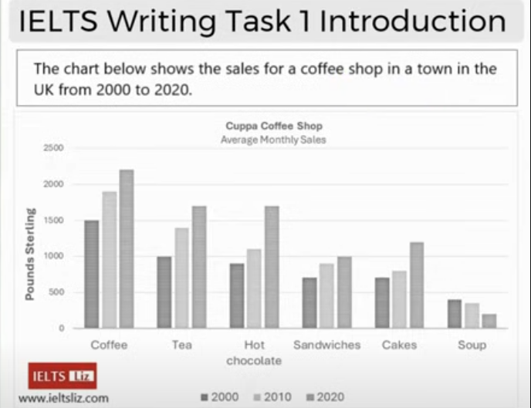

**A wrong example**

The diagram below give ~~the~~ information for the sales of, for example tea, coffee, hot chocolate, food in a cafe. which locates in an English village, from 2000 to 2020. Units measure in Pounds Sterling.

***After corrected***

The bar chart gives information for the typical monthly sale of coffee, tea, hot chocolate, sandwiches, cakes and soup for Cuppa Coffee Shop, which is located in a British town, between 2000 and 2020. Units are measured in pound sterling.

Analyses:

There are 15 mistakes in total.

1, It is not a diagram but a bar chart.

2, “below” : The bar chart is neither below nor above.

3, “the information”: The definite article “the” should not be used here because “infromation” is mentioned for the first time.

4, “the sales” : It only gives an overall/general idea. Use “typcally monthly sale”

5, “for example”: We are going to report the factual information in Task 1 not give examples.

**“tea, coffee, hot chocolate, food…”**

6, These categories are in wrong order.

7, The last three categories should not be summarised because the three drinks have been listed one by one. If there were only a few categories in a bar chart, it would be no problem to list them all. But if there were many ones, they should be summarised. In the following bar chart , we should write that “nine ages groups” instead of listing them all because there are many groups.

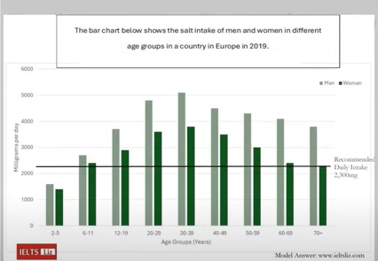

8, There should be an “and” before the last category.

9, “cafe”: This word could not used to paraphrase “coffe shop” because it has a different meaning.

**“which locates in an English village”:**

10, “locates” : “tea, coffee, hot chocolate, food…”

11, “in English” : In the description it is “UK” which means the whole Britain while “English” means “of England”. It is a big mistake here.

12, “village”: It is a town not a village. “cities > towns > villages > hamlets”

13, “from…to…”: They are in the description we should easily paraphrase it by “between…and…”. Don’t ignore it and everyone of all levels of English should use different words from the decription if possible.

**“Units measure in Pound Sterling”**

14, “measure”: are measured (It should be a passive voice.)

15, “Pound Sterling”: Initial capital words are usually used in titles and bar charts like this one but when you use them in sentences they should be grammatically correct, namely they can’t be capitialised.